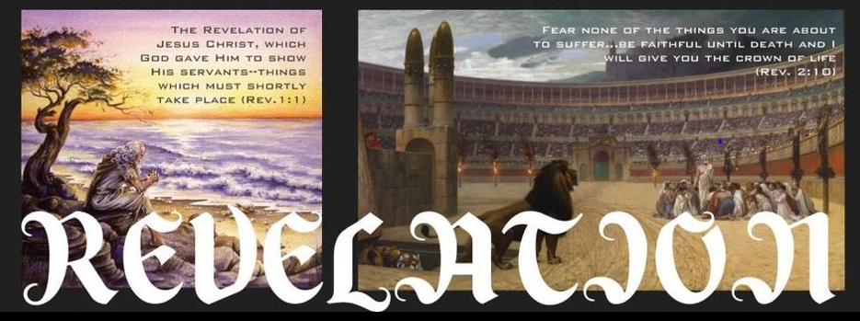
Chapter One – Introduction and Appearance of Jesus.
Introduction (1-9)
- To whom is the book written?
- Where was John the author?
- What does the book say about the time frame of its contents? (v1, v3)

Jesus appears to John (10-20)
- How did John react to the appearance of Jesus?
- What does Jesus tell John to do?

Chapter Two and Three – Letters To The Seven Churches
Briefly summarize the strengths and weaknesses of each of the seven churches. Note especially any reference to persecution that the church was facing.
 | Strengths / Good | Weaknesses / Bad | Ref. To Persecution
Ephesus
Smyrna
Pergamon
Thyatira
Sardis
Philadelphia
Laodicea

Chapter 4 and 5 – Vision of God on His Throne.
- Who is present around the throne and what are they doing?
- What does God hold in His right hand?
- Why did John weep?
- Who is able to open the seals?
- How is Jesus described in this chapter?

Chapter 6 – Opening of the first six seals.
- Briefly describe the events associated with the opening of the first 4 seals.

- When the 5th seal is opened, who does John see?
- Describe the events associated with the opening of the 6th seal.
- What declaration is made after the opening of the 6th seal? (6:17)

Chapter 7 – 144,000 on Earth (1-6) and the Great Multitude in Heaven (9-17).
- As the chapter begins what are the four angels doing?
- How are the 144,000 described?
- How does the 144,000 differ from the group beginning in verse 9?
- What else do we know about the great multitude in heaven?

Chapter 8 – Opening of the 7th Seal / First 4 Trumpets
- What did John see when the 7th seal was opened?
- What act preceded the sounding of the trumpets? (3-5)
- Briefly describe the message of the first 4 trumpets.

- What ominous warning is given at the end of chapter 8? (v13)

Chapter 9 – The 6th and 7th Trumpets
- What happens during the sounding of the 6th trumpet? (v1)
- What happens during the sounding of the 7th trumpet? (v13)
- How does the world react to all the death of 1/3 of mankind? (v18-21)

Chapter 10 - An Angel with A Little Book.
- What do we know about the contents of the little book? (v1-4, v8-11)
- In 3 and 4 we are told about 7 Thunders. What do we know about them?
- What are we told will be accomplished during the sounding of the 7th trumpet? (v5-7)

Chapter 11 – Two Witnesses / Sounding of the 7th Angel.
- As the chapter begins John is given a measuring rod. What is to be measured? What is to be left out?
- Describe the work of the two witnesses we read about in 3-13.
- How does the world react to their resurrection?
- What happens during the sounding of the 7th angel? (verse 15-19)

Chapter 12 – The Woman and the Dragon.
- Chapter 12 is described as a great sign that appeared in heaven. Read over this story. What similarities do you see between it and the New Testament story of Jesus?
- Having failed to defeat the woman and her son, what is the dragon intent upon doing at the end of the chapter (v17)?

Chapter 13 – The Devil’s Allies On Earth.
- Using verses 2, 4, and 12-15; note how these beasts are related to one another and also to the dragon.
- Using verses 6 and 7, then 15-17, what is the disposition of the beasts towards God and Christians?

Chapter 14 – God’s People In Heaven / Warnings Issued To Those On Earth
- In this chapter we read again about 144,000. Where are they and what are they doing?
- Next, beginning in verse 6, 3 Flying Angels, issue what warnings to those living on earth?
- What event takes place at the end of the chapter (15-20)?

Chapter 15 – Prelude to the Bowls of Wrath.
- What does verse 1 say about the 7 last plagues?
- What were the 7 angels given in verse 7?
- How is the pouring out of a bowl differing from the opening of a seal or sounding of a trumpet?

Chapter 16 –
- Briefly describe the events associated with the pouring out of the bowls of wrath. \

- The Battle of Armageddon is described in 13-21. Who is in this battle and who wins the battle?

Chapter 17 – The Harlot.
  - Comparing 13:1 and 17:3 what is the relationship between the woman (the Harlot) and the beast rising out of the sea in Chapter 13?
  - How is the woman identified in verse 18?
  - What about her description might appropriately describe Rome in the first century?

Chapter 18 – The Fall of Babylon.
- What announcement is made by an angel as the chapter begins?
- Who mourns the fall of Babylon?
- Who rejoices?
- What great crime of the harlot is emphasized in verse 24?

Chapter 19 – Victory over the Harlot, Beast, and False Prophet
- What is heaven celebrating as chapter 19 begins? (19:1-9)
- How does John react to all this good news?
- How is Jesus described beginning in verse 11?
- Who does Jesus defeat in verse 19-20?

Chapter 20 - Destruction of Satan and Final Judgment.
- Review from Chapter 13 - Who were the beast and false prophet?
- What happened to them at the end of chapter 19?
- What happens to Satan in chapter 20? (v1-2
- Is this his final end? (v7)
- When is his final end recorded?
- What event follows next (beginning in verse 11)?

Chapter 21 and 22 – The New Heavens and New Earth.
- We will consider the New Heavens and New Earth of Chapter 21 and 22 as a description of heaven. To what three things is it compared?
- In 21:2
- Beginning in 21:10
- Beginning in 22:1

- What is most appealing to you about these descriptions?

Chapter 22:6-21 - Recap and Final Warnings.
What about these warnings are appropriate as a summary to the book?

